1. 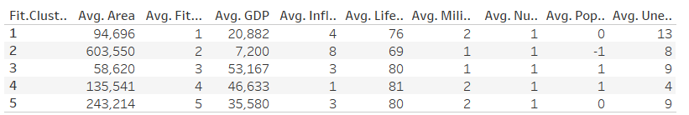

The first cluster has the average area of 94,696, average GDP 20,882, average inflation 4, average life expectancy 76, average military 2, average population growth 0, average unemployment 13.

The first cluster has the average area of 603,550, average GDP 7,200, average inflation 8, average life expectancy 69, average military 1, average population growth -1, average unemployment 8.

The first cluster has the average area of 94,696, average GDP 53,167, average inflation 3, average life expectancy 80, average military 1, average population growth 1, average unemployment 9.

The first cluster has the average area of 94,696, average GDP 46,633, average inflation 1, average life expectancy 81, average military 2, average population growth 1, average unemployment 4.

The first cluster has the average area of 94,696, average GDP 35,580, average inflation 3, average life expectancy 80, average military 2, average population growth 0, average unemployment 9.

1. 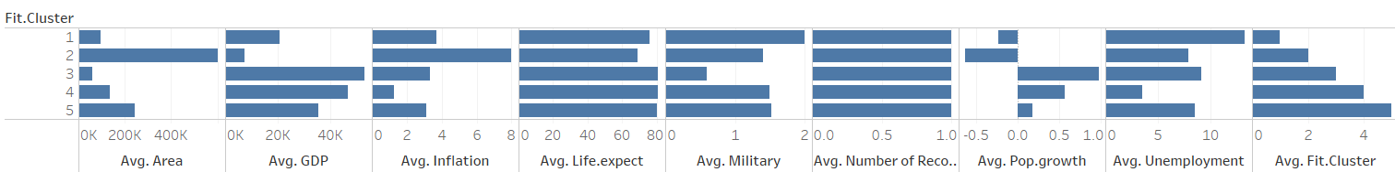

This one is better. It is more clear than the vertical bar chart since there are negative numbers

1. 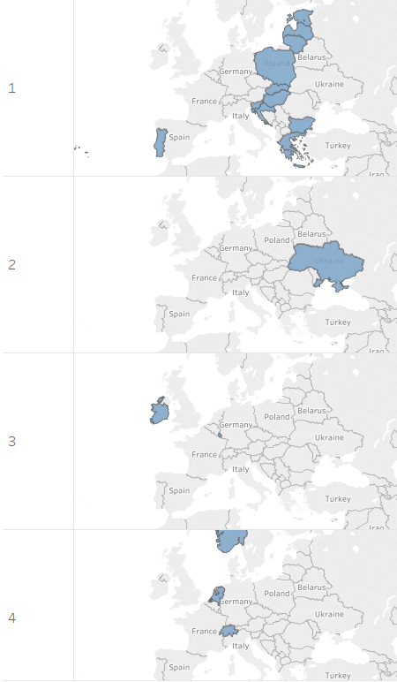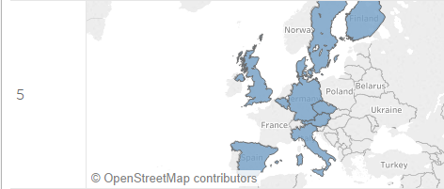
2. 